1)
1)

#include <stdio.h>
int main()
{
int matrix[10][10], sparse[50][3], transpose[50][3];
int rows, cols, i, j, k = 1;
printf("Enter number of rows and columns: ");
scanf("%d %d", &rows, &cols);
printf("Enter the matrix:\n");
for (i = 0; i < rows; i++)
for (j = 0; j < cols; j++)
scanf("%d", &matrix[i][j]);
sparse[0][0] = rows;
sparse[0][1] = cols;
for (i = 0; i < rows; i++)
{
for (j = 0; j < cols; j++)
{
if (matrix[i][j] != 0)
{
sparse[k][0] = i;
sparse[k][1] = j;
sparse[k][2] = matrix[i][j];
k++;
}
}
}

sparse[0][2] = k - 1;

printf("\nSparse Matrix (Triplet Form):\n");
printf("Row Col Val\n");
for (i = 0; i <= sparse[0][2]; i++)
printf("%d %d %d\n", sparse[i][0], sparse[i][1],
sparse[i][2]);

transpose[0][0] = sparse[0][1];
transpose[0][1] = sparse[0][0];
transpose[0][2] = sparse[0][2];

k = 1;
for (i = 0; i < sparse[0][1]; i++)
{
for (j = 1; j <= sparse[0][2]; j++)
{
if (sparse[j][1] == i)
{
transpose[k][0] = sparse[j][1];
transpose[k][1] = sparse[j][0];
transpose[k][2] = sparse[j][2];
k++;
}
}
}

printf("\nTranspose of Sparse Matrix:\n");
printf("Row Col Val\n");
for (i = 0; i <= transpose[0][2]; i++)
printf("%d %d %d\n", transpose[i][0],
transpose[i][1], transpose[i][2]);

return 0;
}
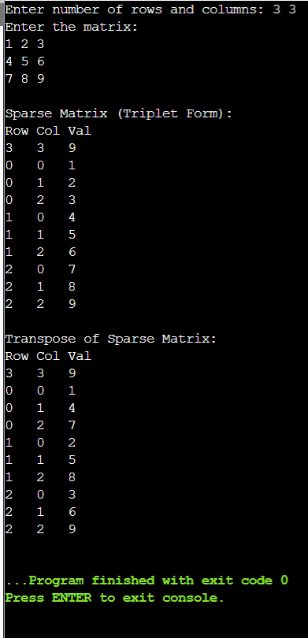

2)
#include <stdio.h>
int main()
{
int r1, c1, r2, c2;
int a[50][50], b[50][50];
int t1[100][3], t2[100][3], t3[200][3];
int i, j, k1 = 1, k2 = 1, k3 = 1;
printf("Enter rows and columns of Matrix 1: ");
scanf("%d %d", &r1, &c1);
printf("Enter elements of Matrix 1:\n");
for(i = 0; i < r1; i++)
for(j = 0; j < c1; j++)
scanf("%d", &a[i][j]);
printf("Enter rows and columns of Matrix 2: ");
scanf("%d %d", &r2, &c2);
printf("Enter elements of Matrix 2:\n");
for(i = 0; i < r2; i++)
for(j = 0; j < c2; j++)
scanf("%d", &b[i][j]);
if(r1 != r2 || c1 != c2)
{
printf("Size is not same");
return 0;
}
t1[0][0] = r1;
t1[0][1] = c1;

for(i = 0; i < r1; i++)
for(j = 0; j < c1; j++)
if(a[i][j] != 0)
{
t1[k1][0] = i;
t1[k1][1] = j;
t1[k1][2] = a[i][j];
k1++;
}

t1[0][2] = k1 - 1;

t2[0][0] = r2;
t2[0][1] = c2;

for(i = 0; i < r2; i++)
for(j = 0; j < c2; j++)
if(b[i][j] != 0)
{
t2[k2][0] = i;
t2[k2][1] = j;
t2[k2][2] = b[i][j];
k2++;
}

t2[0][2] = k2 - 1;

printf("\nSparse Matrix 1 (Triplet Form):\n");
for(i = 0; i < k1; i++)
printf("%d %d %d\n", t1[i][0], t1[i][1], t1[i][2]);

printf("\nSparse Matrix 2 (Triplet Form):\n");
for(i = 0; i < k2; i++)
printf("%d %d %d\n", t2[i][0], t2[i][1], t2[i][2]);

i = 1;
j = 1;

t3[0][0] = r1;
t3[0][1] = c1;

while(i < k1 && j < k2)
{
if(t1[i][0] == t2[j][0] && t1[i][1] == t2[j][1])
{
t3[k3][0] = t1[i][0];
t3[k3][1] = t1[i][1];
t3[k3][2] = t1[i][2] + t2[j][2];
i++;
j++;
k3++;
}
else if(t1[i][0] < t2[j][0] || (t1[i][0] == t2[j][0] &&
t1[i][1] < t2[j][1]))
{
t3[k3][0] = t1[i][0];
t3[k3][1] = t1[i][1];
t3[k3][2] = t1[i][2];
i++;
k3++;
}
else
{
t3[k3][0] = t2[j][0];
t3[k3][1] = t2[j][1];
t3[k3][2] = t2[j][2];
j++;
k3++;
}
}

while(i < k1)
{
t3[k3][0] = t1[i][0];
t3[k3][1] = t1[i][1];
t3[k3][2] = t1[i][2];
i++;
k3++;
}

while(j < k2)
{
t3[k3][0] = t2[j][0];
t3[k3][1] = t2[j][1];
t3[k3][2] = t2[j][2];
j++;
k3++;
}

t3[0][2] = k3 - 1;

printf("\nSum Sparse Matrix (Triplet Form):\n");
for(i = 0; i < k3; i++)
printf("%d %d %d\n", t3[i][0], t3[i][1], t3[i][2]);
return 0;
}
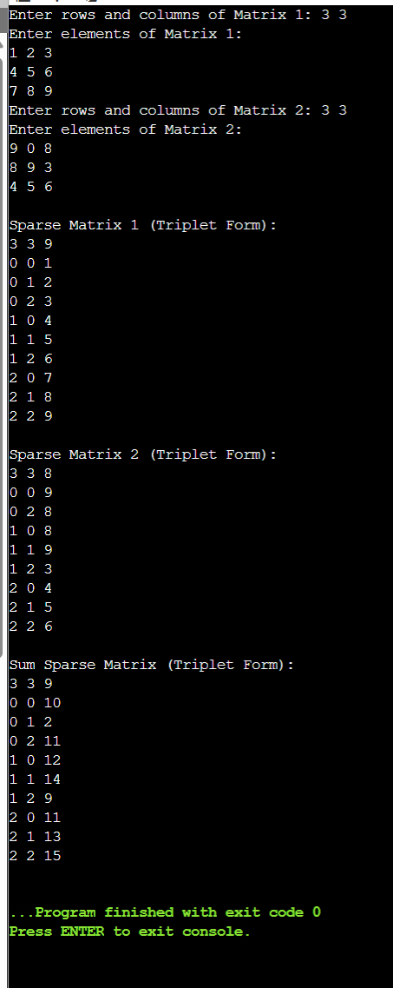

3)
#include <stdio.h>
int main()
{
int n, i;
int p1[50], p2[50], sum[50];
printf("Enter degree of polynomial: ");
scanf("%d", &n);
printf("Enter coefficients of first polynomial:\n");
for(i = 0; i <= n; i++)
scanf("%d", &p1[i]);
printf("Enter coefficients of second polynomial:\n");
for(i = 0; i <= n; i++)
scanf("%d", &p2[i]);
for(i = 0; i <= n; i++)
sum[i] = p1[i] + p2[i];
printf("Resultant polynomial:\n");
for(i = n; i >= 0; i--)
{
if(sum[i] != 0)
{
if(i == 0)
printf("%d", sum[i]);
else
printf("%dx^%d + ", sum[i], i);
}
}
return 0;
}
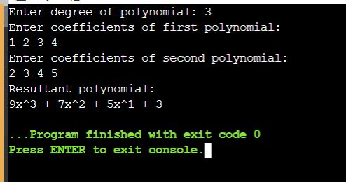

4)
#include <stdio.h>
int main()
{
int d1, d2, i, j;
int p1[50], p2[50], res[100];
printf("Enter degree of first polynomial: ");
scanf("%d", &d1);
printf("Enter coefficients of first polynomial:\n");
for(i = 0; i <= d1; i++)
scanf("%d", &p1[i]);
printf("Enter degree of second polynomial: ");
scanf("%d", &d2);
printf("Enter coefficients of second polynomial:\n");
for(i = 0; i <= d2; i++)
scanf("%d", &p2[i]);
for(i = 0; i <= d1 + d2; i++)
res[i] = 0;
for(i = 0; i <= d1; i++)
for(j = 0; j <= d2; j++)
res[i + j] += p1[i] * p2[j];
printf("Resultant polynomial:\n");
for(i = d1 + d2; i >= 0; i--)
{
if(res[i] != 0)
{
if(i == 0)
printf("%d", res[i]);
else
printf("%dx^%d + ", res[i], i);
}
}
return 0;
}
